Deploy a Web Application to Kubernetes using Minikube.
STEP 1 - Start Minikube
minikube start

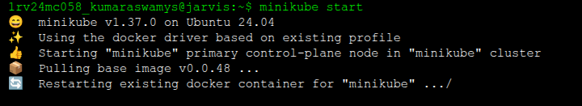

STEP 2 - Check Minikube Status
minikube status
You should see:
host: Running
kubelet: Running
apiserver: Running
kubeconfig: Configured
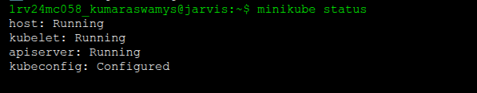

STEP 3 - If Minikube is not running, restart it
minikube delete
minikube start --driver=docker

STEP 4 - Create the Deployment file (nginx-deployment.yaml)
Create a new file:
nginx-deployment.yaml
apiVersion: apps/v1
kind: Deployment
metadata:
name: nginx-deployment
spec:
replicas: 2
selector:
matchLabels:
app: nginxtemplate:
metadata:
labels:
app: nginxspec:
containers:
- name: nginx
image: nginx:latest
ports:
- containerPort: 80

STEP 5 - Apply the deployment
kubectl apply -f nginx-deployment.yaml

STEP 6 - Check Deployment & Pods
kubectl get deployments
kubectl get pods
You should see 2 pods running.

STEP 7 -Expose the Deployment as a Service
kubectl expose deployment nginx-deployment \
--type=NodePort \
--port=80
This creates a service that exposes Nginx to your system.

STEP 8 - Check Services
kubectl get services
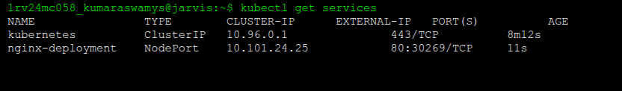

A service named nginx-deployment should appear .

STEP 9 - Access the Webpage
Minikube provides a shortcut to open the app:minikube service nginx-deployment
This will open the browser showing the Nginx Welcome Page.

STEP 10 — Clean Up
Delete all pods
kubectl delete pods --all
Delete all services
kubectl delete svc --all
Delete all deployments
kubectl delete deployments --all